**Invitation to speak at a conference**

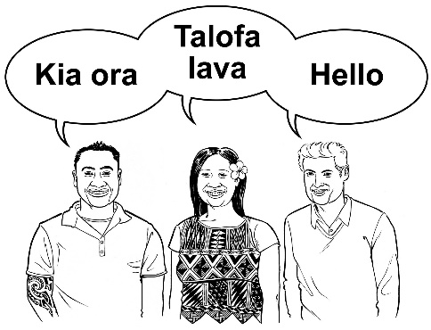

**ASID New Zealand is running a conference called:**

***Data,* *Design* and *Delivery:***

**Research to support with people with a learning (intellectual) disability**



**When? 17 March 2025**

**Where? Harbourside Function**

**Venue (Shed 22),**

**Wellington**

We are inviting people to speak at the conference.

**What can I speak about?**

You can speak about big and small topics.

This could include your dreams, health,

education, housing, work, fun activities,

or safety and safeguarding.

**If you would like to be a speaker at the ASID conference, you need do these things:**

|  |  |
| --- | --- |
|  | 1. Fill in the ‘Interested in Speaking’ form. This tells us that you would like to be a speaker at the conference. 2. Email this form to [info@asid.asn.au](mailto:info@asid.asn.au) by 30th October 3. The ASID committee will decide and let you know by the 30th of November if you will be speaking at the conference. |

If you need support with filling the form, or if you have any other questions, you can contact Hemant Thakkar on:



: 0274193928



: [hemantthakkar@xtra.co.nz](mailto:hemantthakkar@xtra.co.nz)

**ASID New Zealand conference**

**Interested in Speaking form**

|  |  |
| --- | --- |
|  | **Names of the speakers:** |
|  | **The main speaker’s mobile phone number:** |
|  | **The main speaker’s email address:** |
| **Title?** | **The name (title) of your presentation:** |
|  | **How long would you like to speak for?**  (choose one):   * Long presentation (60 minutes) * Short presentation (30 minutes) |
|  | **What you will speak about?**  Tell us in less than 150 words. |
|  | **Tell us how your presentation is about putting data or research into practice.**  Tell us in less than 150 words. |

**Thank you!**