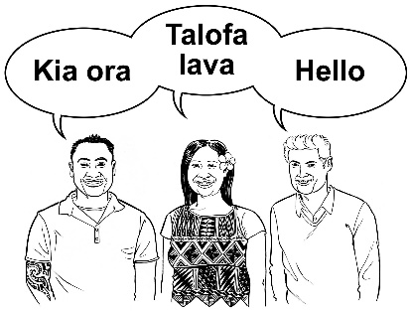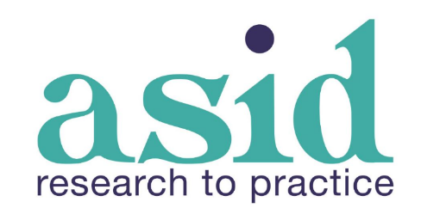

**Invitation to speak at ASID New Zealand Conference**

***Data,* *Design* and *Delivery:***

**Research to support with people with a learning (intellectual) disability**

**Date:** 17 March 2025

**Venue:** Harbourside Function Venue (Shed 22), Wellington

The people attending our conference will include people with learning (intellectual) disability, as well as researchers, service providers, whānau and family members, and others.

The conference is a great way to share your work with the community, to network with others, and to learn together.

**Send us your Expression of Interest**

All speakers are welcome, including:

* People with lived experience of learning (intellectual) disability
* Whānau and family members
* Researchers (including student researchers)
* Service providers
* Health and disability professionals
* Government officials

There will be 2 types of sessions:

* **Plenary sessions** : These are 1-hour long, including 15 minutes for questions.
* **Strand sessions** : These are 30 minutes long including 10 minutes for questions.

Presenters should explain how they have translated data or research into practice and other innovations. You could speak about big and small topics. This could include dreams and aspirations, health, education, housing, work, recreation and fun activities, or safety and safeguarding.

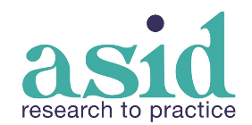**Expression of Interest Form**

|  |  |
| --- | --- |
| **Presenter/s name** |  |
| **Where you work; or**  **Connection with the sector** |  |
| **Mobile phone number** |  |
| **Email address** |  |
| **Title of your presentation** |  |
| **A summary of your presentation**  (less than 150 words) |  |
| **An explanation of how your presentation aligns with the conference theme**  (less than 150 words) |  |
| **Tell us about the presenter/s**  (less than 150 words) |  |
| **Presentation Type (select one)** | Plenary  Strand |

**Thank you for your interest in presenting at our conference!**

* Please email this form to [info@asid.asn.au](mailto:info@asid.asn.au) **by 30 October 2024**.
* We will get back to you with a response **by 30 November 2024**.